

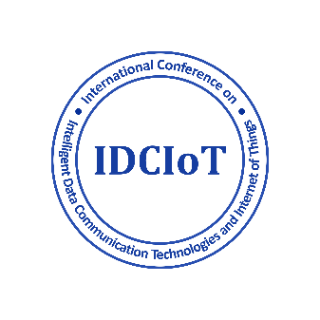

Acceptance of Paper for IDCIOT 2025

Dear Author[s]

We are delighted to inform you that your paper titled **“A DATA-DRIVEN APPROACH FOR PREDICTING VEHICLE COMPONENT FAILURES”** has been accepted for presentation at the Third International Conference on Intelligent Data Communication Technologies and Internet of Things (IDCIOT 2025), to be held from 5-7 February 2025 at REVA University, Bengaluru, India.

The reviewers have carefully evaluated your submission and appreciated the quality of your research. We believe that your contribution will add significant value to the conference.

The detailed schedule of the conference will be shared closer to the event. We look forward to your valuable participation and an engaging discussion at IDCIOT 2025.

Thank you for your contribution, and congratulations on your acceptance!

Sincerely,

Conference Chair, IDCIOT2025